Module 3 Assignment
Blue Teams GitHub Repo

Assignment Breakdown by Person:
We broke down the assignments by the pages we designed in module 3, and which tables touched those pages the most. As a group, we discussed (at length) the different aspects of the tables and their relationships. I added many of the decisions we reached as a group, as they relate to how, in a production environment, we might want it to look like this, but it got WAY beyond the spec of the project and so we decided to just note that in a “real” project, it may look different but in our project it was fine to do it this way.
Moving forward, Robert is in charge of all schema changes to the Database, including keeping the ERD updated and SQL update scripts as needed. This helps keep the database consistent with the ERD, having only one developer touch it.
Sara:
- Kanban Board Creation – Update own Kanban events
- Tables: SlipSize, WaitList, BoatOwnership

Miguel:
- Update Own Kanban Events
- Tables: Customer, Boat

Carolina:
- Update Own Kanban Events
- Tables: Reservation, TerminationNotice
- Took on being in charge of keeping track of Business Rules in a single space.

Robert:
- Update Own Kanban Events
- Tables: DatabaseVersion, Dock, Employee, Slip, Contact
- Compile the ERD and ERD.md

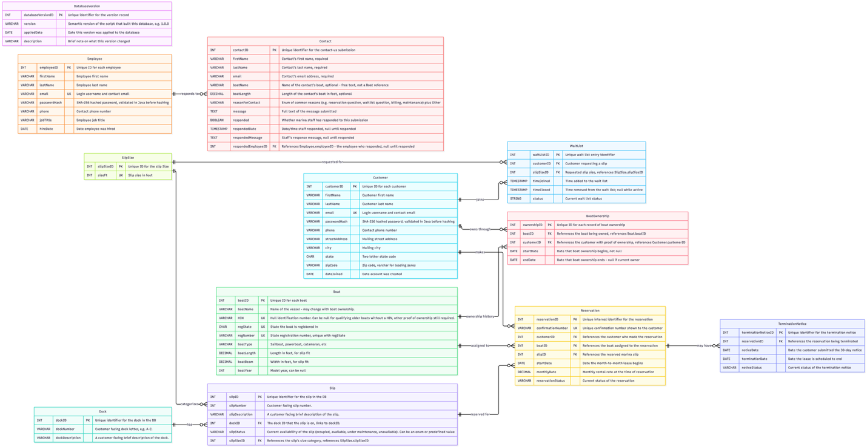

This PNG is hard to see in the Word document, so we included it as part of the upload.
The ERD was created using Mermaid Code and their website to automatically create a visual ERD.

Database Design Decisions:
• DatabaseVersion (Table 0) is a standalone metadata table, with no FKs in or out, holding one row that records which version of the build script last created the database (version, appliedDate, description). MySQL has no built-in concept of a "database version" the way some other systems do, so this is hand-rolled. It makes a running instance self-describing: anyone connected to it can query DatabaseVersion to confirm which schema/seed-data version they are looking at, instead of needing to track down the .sql file that built it. Since the whole database is dropped and recreated on every run of the script (see DROP DATABASE IF EXISTS in MoffatBayMarinaDB_V1-0-0.sql), this stays a single current-version row rather than an accumulating history/migration log.
• PascalCase and camelCase Table names are PascalCase and column names are camelCase, following standard conventions.
• ID is capitalized in table names As an example, slipID or customerID rather than slipId or customerId.
• No waitlist queue position stored in database even though this means Marina personnel cannot manually "bump" people up the list. An intentional design decision, made to keep within the scope of the design specifications, to simplify the database. Position in queue can be determined by calculating the time joined and seeing how many people joined before that person did.
• Customer.email has a UNIQUE constraint at the database level. Email doubles as the login username, so app-level checks alone are not enough. Two signups submitted at the same time could both pass an app-level "is this email taken" check before either is saved. The DB constraint is the actual guarantee against duplicate logins.
• Boat year is stored as INT, not MySQL's YEAR type. YEAR is not standard SQL and maps awkwardly through JDBC, so a plain INT was used instead, simpler on both the SQL and Java sides. This gap was noted by Claude and verified with a Google search.
• Boat table adds regState and regNumber columns, for a composite UNIQUE (regState, regNumber). Registration numbers are only unique per state. For example, FL and GA could issue the same number, so a single-column UNIQUE on the number alone was not correct. Decided and owned by Fernandez, M. rather than needing full team sign-off, since the change is contained to the Boat table and nothing else references it.
• BoatOwnership table tracks boat ownership over time via a Customer <-> Boat many-to-many relationship, rather than a direct Boat.customerID FK. This lets the marina keep ownership history when a boat changes hands instead of only ever knowing the current owner. The current owner is the BoatOwnership row with endDate IS NULL. Proposed by White, S. Agreed to by the rest of the team. This is noted as beyond the scope of the original requirements but did not cost much extra to add.
• Boat.HIN, a nullable UNIQUE Hull Identification Number, is an additional way to identify a boat alongside regState/regNumber (proposed by White, S. alongside BoatOwnership). Nullable to allow qualifying older boats without a HIN, provided other proof of ownership is on file.
• Slip.slipSizeID FK replaces the old slipSize enum-style column. Slip size is now defined once in SlipSize, which also carries a UNIQUE constraint on sizeFt so the same size cannot be entered twice, and referenced from Slip, instead of being duplicated inline as a checked (26, 40, 50) value.
• Reservation.customerID is a direct FK. The customer tied to a reservation is reachable directly, rather than only by joining through Boat, matching how Customer "makes" Reservation is drawn in the diagram.
• Contact table has no FK to Customer or Boat. It holds Contact Us page submissions, and a submitter may not be a registered customer yet, so boatName/boatLength are free text the visitor typed in, not references into Boat.
• Contact.message/Contact.respondedMessage use TEXT, not VARCHAR. A Contact Us message and a staff reply to it have no natural length cap, so an unbounded TEXT column was used instead of guessing at a VARCHAR limit.
• Contact.reasonForContact is a VARCHAR holding an enum-style value (common reasons plus "Other"), not a dedicated lookup table, matching how Slip.slipStatus already represents its enum in this diagram. The exact reason list is an implementation detail for the CREATE TABLE script, not the ERD.
• Contact.respondedEmployeeID is a nullable FK to Employee.employeeID (Employee ||--o{ Contact : "responds to"), null until a submission is answered, mirroring how responded, respondedDate, and respondedMessage are already null until responded.
• Employee table mirrors Customer's account fields (email as a UNIQUE login username, passwordHash, phone) plus jobTitle and hireDate, since staff need to log in and respond to Contact submissions the same way customers log in to make reservations.
• passwordHash (both Employee and Customer) is a SHA-256 digest, computed with MySQL's SHA2(<plaintext>, 256) to match how the seed data in the database creation script is hashed. This is the project's actual password hashing scheme (unsalted), not a placeholder to be swapped out later, since no further "real auth" phase follows this submission.
- The password hashing done in SQL lets us load a password hash into the table using SHA-256. SHA2('Password1', 256) enters into the database as 19513fdc9da4fb72a4a05eb66917548d3c90ff94d5419e1f2363eea89dfee1dd.
- This means our program MUST use SHA-256 hashing (unsalted) in order to authenticate correctly.

